**A Comparative Analysis of Massive MIMO and Small Cell Networks in 5G Systems**

Mohamed Eisameldin Abdelrahman Ahmed, Ammar Bathich

Faculty of Computer & Information Technology, Al-Madinah International University  
Kuala Lampur, Malaysia

CL521@lms.mediu.edu.my, ammar.bathich@mediu.edu.my

***Abstract—*** ***The deployment of 5G wireless networks has transformed connectivity by delivering unprecedented speed, reliability, and capacity. This study examines two fundamental technologies enabling 5G performance: Massive Multiple-Input Multiple-Output (Massive MIMO) and Small Cell Networks. Their effectiveness is evaluated based on key performance metrics, including spectral efficiency, latency, and energy efficiency, under various deployment scenarios. Massive MIMO enhances network capacity and reliability through large antenna arrays and advanced beamforming techniques, making it well-suited for wide-area coverage. However, challenges such as computational complexity, energy consumption, and mobility constraints must be addressed. Conversely, Small Cell Networks improve capacity and coverage in dense urban areas by utilizing localized, low-power base stations. Despite their benefits, they pose challenges related to interference management, backhaul requirements, and deployment costs. This research employs simulation-based analysis to compare the performance of these technologies across different user densities and deployment scales. The results indicate that Massive MIMO is more effective in wide-area networks with moderate user densities, whereas Small Cell Networks excel in high-density urban environments by reducing latency and increasing frequency reuse. Additionally, hybrid deployment strategies integrating both technologies prove optimal for suburban areas, achieving a balance between coverage and capacity. These findings offer practical insights for optimizing 5G network deployments, highlighting the need for scenario-specific approaches. Recommendations include the integration of renewable energy sources for sustainability and the adoption of hybrid architectures to meet diverse connectivity demands. This study contributes to the advancement of 5G infrastructure, supporting the development of efficient, scalable, and sustainable next-generation wireless communication systems.***

***Keywords—5G, Massive MIMO, Small Cell Networks, Spectral Efficiency, Latency, Energy Efficiency.***

1. **INTRODUCTION**

The emergence of fifth-generation (5G) wireless communication represents a transformative shift in connectivity, delivering unprecedented speed, capacity, and reliability. With its support for diverse applications, including enhanced mobile broadband (eMBB), ultra-reliable low-latency communications (URLLC), and massive machine-type communications (mMTC), 5G serves as a fundamental enabler of the digital era. As the demand for high-performance wireless networks increases, innovative technologies such as Massive Multiple-Input Multiple-Output (Massive MIMO) and Small Cell Networks have become integral to 5G infrastructure [1].

Massive MIMO, illustrated in Figure 1, leverages large-scale antenna arrays at base stations to enhance spectral efficiency and signal reliability. By serving multiple users on the same frequency band through spatial multiplexing and beamforming, Massive MIMO significantly boosts network capacity. This approach reduces interference by directing energy toward specific users, making it ideal for high-density urban environments. However, its implementation presents challenges, including high computational complexity, increased power consumption, and the necessity for precise channel state information (CSI) [2-4].

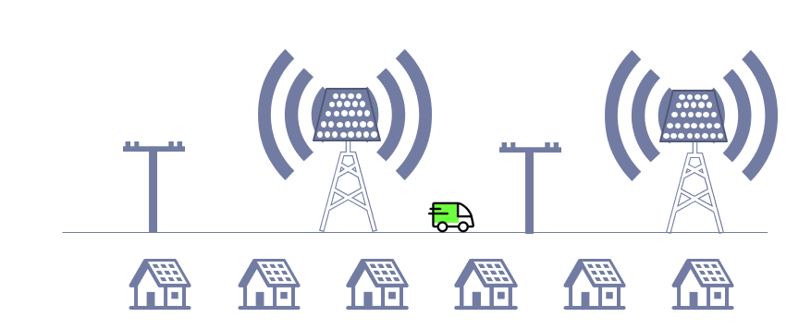

Figure 1: Massive MIMO

Small Cell Networks address capacity limitations and coverage gaps by deploying numerous low-power base stations within localized areas, as depicted in Figure 1. These small cells—comprising femtocells, picocells, and microcells—enhance frequency reuse and alleviate congestion in macro-cellular networks, thereby improving user experience in densely populated environments. Despite these advantages, Small Cell Networks introduce challenges related to interference management, backhaul connectivity, and infrastructure costs.

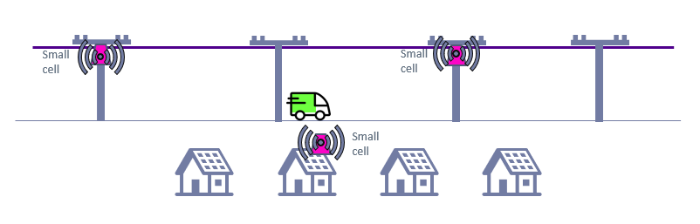

Figure 2: Small Cell Network

Beyond these technologies, 5G advancements include enhanced spectrum utilization techniques such as millimeter-wave (mmWave) frequencies and network slicing. mmWave bands provide higher data rates but suffer from propagation limitations, while network slicing enables customized virtual networks for diverse applications, including autonomous vehicles and telemedicine. These innovations highlight the need for optimized deployment strategies that effectively integrate Massive MIMO and Small Cell Networks[5-7].

The convergence of these technologies presents significant opportunities for 5G networks, particularly in urban, suburban, and rural settings. However, their effective coexistence requires further investigation, focusing on cost, energy efficiency, and scalability to ensure sustainable network evolution.

Selecting the optimal deployment strategy for 5G networks remains a key challenge due to trade-offs between Massive MIMO and Small Cell Networks in terms of performance, cost, and feasibility. Massive MIMO, while highly effective in improving spectral efficiency, demands substantial computational resources for beamforming and real-time channel estimation, leading to increased operational complexity. Additionally, mobility constraints, such as short channel coherence times in vehicular networks, further impact its effectiveness[8].

Conversely, Small Cell Networks excel in localized capacity enhancement but introduce issues such as interference and high backhaul connectivity demands. Their dense deployment in urban settings requires sophisticated interference management and reliable high-capacity backhaul solutions. Moreover, the operational energy consumption of multiple small cells raises sustainability concerns.

Economic feasibility also plays a crucial role, as network operators must balance the high initial costs of Massive MIMO infrastructure with the recurring expenses of deploying and maintaining dense Small Cell Networks. These financial considerations necessitate meticulous planning to avoid network inefficiencies and ensure cost-effective 5G deployment.

This study seeks to address a critical question: How do Massive MIMO and Small Cell Networks compare in terms of network capacity, latency, energy efficiency, and deployment feasibility? A deeper understanding of these trade-offs is essential for guiding stakeholders in designing optimal 5G network architectures.

The primary objectives of this study are to determine the most effective deployment scenarios for Massive MIMO and Small Cell Networks in urban, suburban, and rural environments, while providing simulation-based insights to optimize their integration in real-world 5G networks[9]. Additionally, this research aims to compare the performance of these technologies across key metrics, including network capacity, latency, and energy efficiency. Furthermore, it seeks to evaluate and validate their performance under varying deployment conditions using simulation-based analysis, offering valuable insights for optimizing 5G network deployments.

1. **MASSIVE MIMO AND SMALL CELL NETWORKS**

This study adopts a structured Research Methodology Framework to assess and compare the performance of Massive MIMO and Small Cell Networks in 5G deployments across four key phases: identifying suitable deployment scenarios for each technology, providing simulation-based insights to optimize their integration, comparing their effectiveness based on key performance metrics, and evaluating and validating their performance under varying network conditions using simulation results. These phases are executed through a five-step methodology, as depicted in Figure 3.

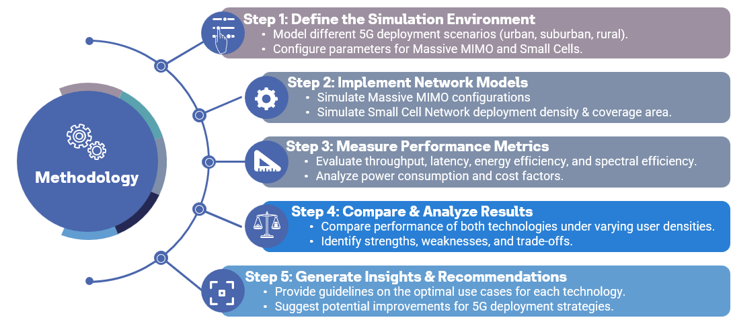

Figure 3 Research Methodology Framework

The methodology is structured into five essential steps as illustrated in Figure 3:

*Step 1: Define the Simulation Environment.*

This step aligns with Objective 1, which aims to identify the most suitable deployment scenarios for Massive MIMO and Small Cell Networks. The simulation environment models diverse 5G deployment conditions, including urban, suburban, and rural areas. Key parameters such as user density, cell density, and mobility constraints are configured to mimic real-world scenarios. This ensures that the study evaluates each technology under relevant operational conditions.

*Step 2: Implement Network Models*

This step directly relates to Objective 2, which focuses on generating insights for optimizing the integration of these technologies.

Massive MIMO: Simulated with varying numbers of antennas (64, 128, and 256 antennas) to evaluate their impact on performance.

Small Cells: Simulated by adjusting cell densities (10, 30, and 50 cells per km²) to analyze network scalability.

Both models are simulated under identical conditions to facilitate a fair comparative analysis, ensuring that the differences in results stem solely from the technologies themselves [10].]

*Step 3: Measure Performance Metrics*

This phase supports Objective 3, which aims to compare the effectiveness of Massive MIMO and Small Cells using key performance indicators. The study evaluates the following metrics:

Spectral Efficiency: Assesses the efficient use of bandwidth.

Latency: Measures delays in data transmission.

Energy Efficiency: Evaluates power consumption per bit transmitted.

Network Capacity & User Density: Determines the number of users supported by each technology.

Deployment Cost: Evaluates both capital (CAPEX) and operational (OPEX) expenses.

The results are extracted from simulation outputs and subjected to statistical comparisons for validation.

*Step 4: Compare & Analyze Results*

This phase is linked to Objective 4, which seeks to validate the performance of each technology under varying conditions.

Massive MIMO is evaluated for its spectral efficiency, latency, and energy efficiency across different antenna configurations.

Small Cells are assessed for their scalability, spectral efficiency, and backhaul limitations across various deployment densities.

The results are analyzed across multiple user densities and network configurations, allowing for trend identification and performance trade-off evaluations.

*Step 5: Generate Insights & Recommendations*

The final step consolidates the findings into actionable recommendations for network operators and policymakers, ensuring that simulation-based insights help optimize real-world 5G deployments. It focuses on offering best practices for hybrid deployments, identifying the most suitable scenarios for each technology, and emphasizing energy-efficient strategies to lower operational costs. These insights aim to support industry stakeholders in making informed decisions about 5G infrastructure investments.

1. **RESEARCH DESIGN**

This study employs a quantitative, simulation-based approach to compare the performance of Massive MIMO and Small Cell Networks in 5G deployments. The research utilizes MATLAB for modeling Massive MIMO systems, focusing on spectral efficiency and latency, and Python for simulating Small Cell Networks, including heatmaps and performance trend analysis. Key performance metrics evaluated include spectral efficiency, latency, and energy efficiency. The comparison is based on parameters such as user density, antenna density for Massive MIMO (ranging from 64 to 256 antennas), and cell density for Small Cells (10 to 50 cells per square kilometer). The simulation is conducted in a controlled environment that reflects real-world conditions, including urban, suburban, and rural areas [11].

Simulation parameters for Massive MIMO include a carrier frequency of 28 GHz, bandwidth of 100 MHz, and varying antenna configurations. Small Cell Networks are modeled with a cell radius of 100m, backhaul latency of 2ms, and transmission power of 20 dBm per cell. Both technologies are evaluated across different user densities (10, 50, and 100 users per cell). Energy efficiency is considered for both technologies, including power consumption for antennas, processing, and cooling in Massive MIMO, and for transmission, backhaul, and overhead in Small Cells. The data generated from simulations is collected and analyzed to calculate the performance metrics for both technologies.

The data analysis involves graphical methods such as 3D bar charts for Massive MIMO and heatmaps for Small Cells to visualize spectral efficiency and performance trends. A comparative analysis is conducted to identify performance trade-offs under varying conditions. The results are validated by comparing them to benchmark studies from existing literature, and sensitivity analysis is carried out to test the robustness of the simulations under different configurations and power constraints. These analytical methods ensure reliable and meaningful insights into the comparative performance of the two technologies [12].

1. **RESULTS AND DISCUSSION**

In this section we present the analysis of the simulation results for Massive MIMO and Small Cell Networks, focusing on key performance metrics such as spectral efficiency, latency, and energy efficiency under varying deployment scenarios. The results show distinct performance characteristics for both technologies, with Massive MIMO offering stable performance even at high user densities, while Small Cell Networks' efficiency drops significantly with increased user load.

1. Spectral Efficiency Analysis

Massive MIMO: The spectral efficiency of Massive MIMO improves as the number of antennas increases, with diminishing returns beyond 128 antennas. As user density increases, spectral efficiency slightly declines due to increased interference and resource sharing. However, even at higher user densities (100 users per cell), Massive MIMO maintains relatively high efficiency, making it ideal for large-scale deployments, especially in suburban and rural areas (Table 1, Figure 4). The technology’s ability to employ spatial multiplexing and frequency reuse contributes to this performance.

|  |  |  |  |
| --- | --- | --- | --- |
| Number of Antennas | User Density (10 Users/Cell) | User Density (50 Users/Cell) | User Density (100 Users/Cell) |
| 64 Antennas | 43.87 | 41.55 | 40.55 |
| 128 Antennas | 44.87 | 42.55 | 41.55 |
| 256 Antennas | 45.87 | 43.55 | 42.55 |

Table 1: Spectral Efficiency of Massive MIMO (bps/Hz)

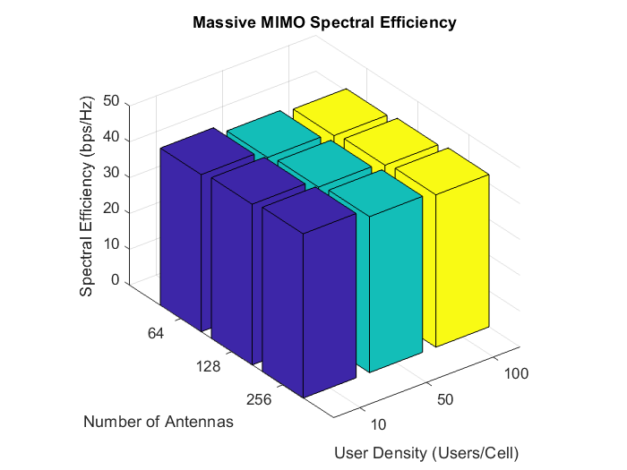

Figure 4: Massive MIMO Spectral Efficiency

Small Cell Networks: The spectral efficiency of Small Cell Networks improves with higher cell density, but performance degrades sharply as user density increases. At low user densities, Small Cells show high efficiency, but this drops significantly as the number of users per cell rises, particularly when the deployment density is lower (Table 2, Figure 5). The technology relies on frequency reuse, which becomes less effective under high user loads, highlighting its suitability for hotspot areas with targeted capacity needs.

|  |  |  |  |
| --- | --- | --- | --- |
| **Cell Density (Cells/km²)** | **User Density (10 Users/Cell)** | **User Density (50 Users/Cell)** | **User Density (100 Users/Cell)** |
| 10 Cells/km² | 15 | 3 | 1.5 |
| 30 Cells/km² | 45 | 9 | 4.5 |
| 50 Cells/km² | 75 | 15 | 7.5 |

Table 2: Spectral Efficiency of Small Cell Networks (bps/Hz)

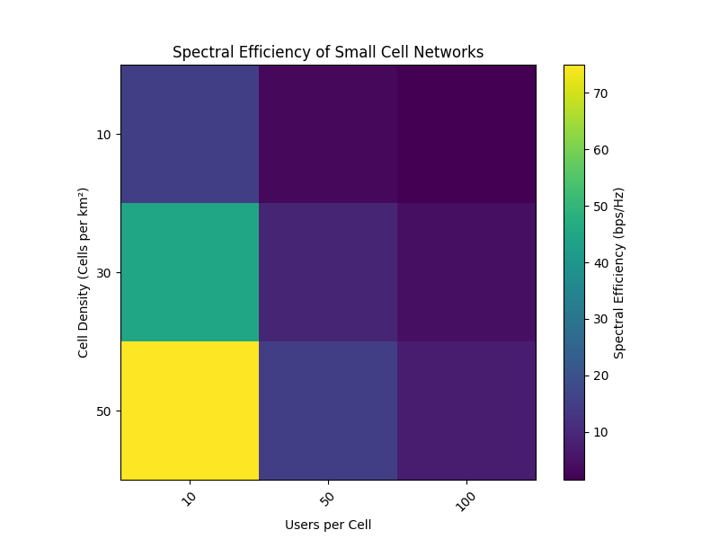

Figure 5: Spectral Efficiency of Small Cell Network

1. Comparative Analysis of Spectral Efficiency

A direct comparison between Massive MIMO and Small Cell Networks reveals that Massive MIMO performs consistently well even with high user density, whereas Small Cells require dense deployments to maintain efficiency. Table 3 summarizes these differences, with Massive MIMO outperforming Small Cells in large coverage areas (suburban, rural), while Small Cells are more suited for high-density urban areas. Despite their strengths, both technologies have trade-offs regarding scalability and infrastructure demands. Figure 6 visually represents the spectral efficiency differences, showing that Massive MIMO is more stable across different user densities, while Small Cells are more efficient with higher deployment density but face significant efficiency loss as user density increases.

|  |  |  |
| --- | --- | --- |
| **Factor** | **Massive MIMO** | **Small Cells** |
| **Performance Stability** | Stable at high user density | Drops significantly with high users |
| **Best Use Case** | Large coverage areas (suburban, rural) | High-density areas (urban) |
| **Scalability** | Works well for large-scale deployments | Requires many small cells for efficiency |
| **Efficiency at 10 users/cell** | 45 bps/Hz (256 antennas) | 75 bps/Hz (50 Cells/km²) |
| **Efficiency at 100 users/cell** | 42.5 bps/Hz (256 antennas) | 7.5 bps/Hz (50 Cells/km²) |

Table 3: Spectral Efficiency Comparison between Massive MIMO & Small Cells

Figure 6: Comparative Spectral Efficiency Analysis for Both Technologies

1. **CONCLUSION AND FUTURE WIRKS**

The evolution of wireless communication has led to the widespread adoption of 5G networks, driven by the need for high-speed connectivity, low latency, and energy efficiency. Massive MIMO and Small Cell Networks have emerged as key technologies for 5G, each with its own strengths and challenges. This study presents a comparative analysis of these technologies, assessing their spectral efficiency, latency, and energy efficiency under various network conditions. The findings show that Massive MIMO excels in spectral efficiency, especially in suburban and rural areas, while Small Cells are more effective in reducing latency in urban environments, though their performance can be affected by high user densities. Energy efficiency varies, with Small Cells offering better power efficiency per user, whereas Massive MIMO consumes more power due to its complex antenna systems. The study highlights that neither technology alone can meet all 5G requirements, suggesting the need for hybrid deployment strategies to balance performance factors. The research contributes by offering a detailed comparison and identifying optimal deployment strategies based on real-world conditions. It also emphasizes the importance of integrating AI and machine learning for optimizing network resources, promoting sustainability through energy-efficient solutions, and paving the way for future advancements in 6G.

1. **REFERENCES**

1.Andrews, J. G., Buzzi, S., Choi, W., et al. (2014). "What Will 5G Be?" IEEE Journal on Selected Areas in Communications, 32(6), 1065–1082.

2.Marzetta, T. L. (2010). "Noncooperative Cellular Wireless with Unlimited Numbers of Base Station Antennas." IEEE Transactions on Wireless Communications, 9(11), 3590–3600.

3.Shi, Y., Sun, Y., Peng, Y., et al. (2020). "Massive MIMO for 5G: Techniques and Challenges." IEEE Wireless Communications, 27(4), 20–26.

4.Dahlman, E., Parkvall, S., Skold, J. (2018). 5G NR: The Next Generation Wireless Access Technology. Academic Press.

5.Boccardi, F., Heath, R. W., Lozano, A., et al. (2014). "Five Disruptive Technology Directions for 5G." IEEE Communications Magazine, 52(2), 74–80.

6.Gupta, A., Jha, R. K. (2015). "A Survey of 5G Network: Architecture and Emerging Technologies." IEEE Access, 3, 1206–1232.

7.Cisco. (2020). "Cisco Annual Internet Report (2018–2023)."

8.Qualcomm. (2019). "Making 5G a Reality: Addressing the Challenges of 5G Deployment."

9.Yang, Z., Li, J., Ge, X., et al. (2017). "Performance Analysis of 5G Millimeter-Wave Massive MIMO Systems with Imperfect Channel State Information." IEEE Transactions on Vehicular Technology, 66(10), 8780–8894.

10.Buzzi, S., et al. (2016). "A Survey of Energy-Efficient Techniques for 5G Networks and Challenges Ahead." IEEE Journal on Selected Areas in Communications, 34(4), 697–709.

11.Sun, S., Rappaport, T. S., Rangan, S., et al. (2014). "MIMO for Millimeter-Wave Wireless Communications: Beamforming, Spatial Multiplexing, or Both?" IEEE Communications Magazine, 52(12), 110–121.

12.Andrews, J. G., Claussen, H., Dohler, M., et al. (2013). "What Will Be the Role of Small Cells in 5G Networks?" IEEE Communications Magazine, 51(10), 90–97.